Tftp setting
- sudo apt-get install xinetd
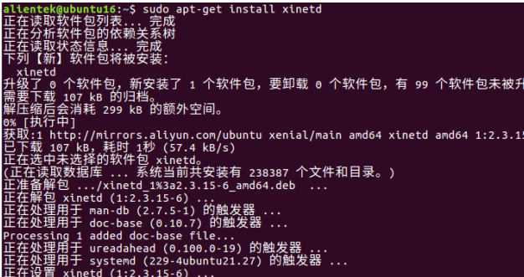
- ls /etc/xinetd.conf
- sudo vi /etc/xinetd.conf
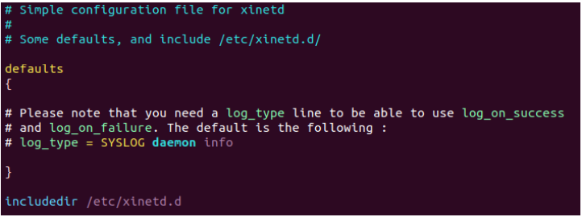
4.
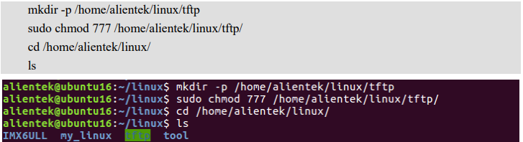

- sudo apt-get install tftp-hpa tftpd-hpa

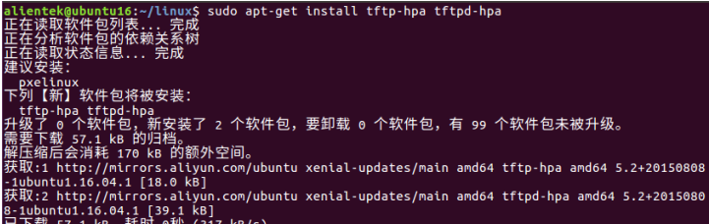
- sudo vi /etc/default/tftpd-hpa
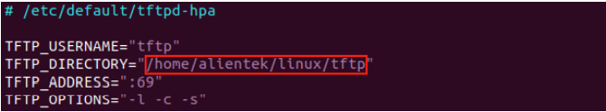
- sudo vi /etc/xinetd.d/tftp
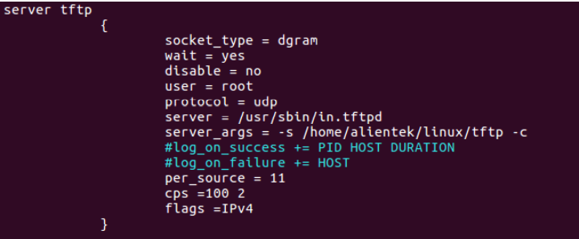
- sudo service tftpd-hpa restart
- sudo service xinetd restart

Nfs setting
- sudo apt-get install nfs-kernel-server
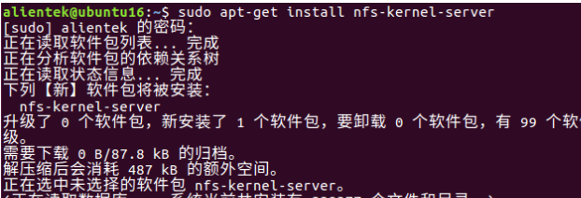
- sudo mkdir /home/alientek/linux/nfs
- sudo chmod 777 /home/alientek/linux/nfs/
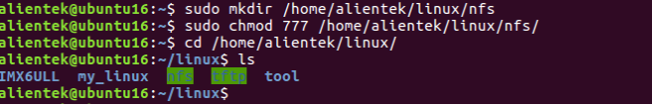
- sudo vi /etc/exports
/home/alientek/linux/nfs indicates the NFS shared directory
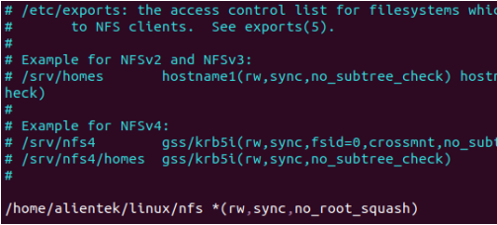

- sudo /etc/init.d/nfs-kernel-server restart

nfs mounts the system
The above describes setting up tftp and nfs environments. You can modify the shared directory as required.The following shared directory is different from the above environment setup directory, but it is also modified in the same way.
- Copy the zImage and device tree dtb files to the tftp shared directory
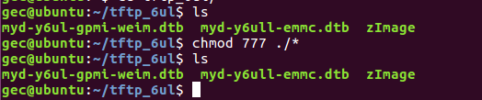
- Create a rootfs directory in the nfs shared directory to store file systems
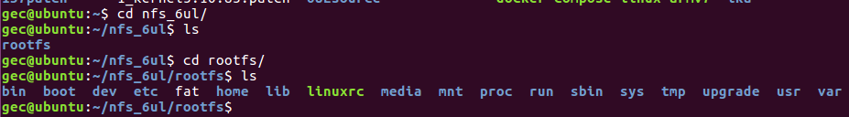
- Set environment variables in the uboot
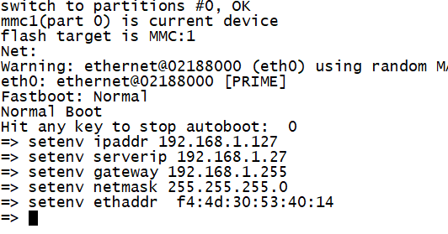
ipaddr is the IP address of the development board
serverip is the IP address of the VM

- Set bootcmd and nfs
- Command

setenv ipaddr 192.168.1.127
setenv serverip 192.168.1.27
setenv gateway 192.168.1.255
setenv netmask 255.255.255.0
setenv ethaddr f4:4d:30:53:40:14
setenv bootcmd 'tftp 80800000 zImage;tftp 83000000 myd-y6ul-gpmi-weim.dtb;bootz 80800000 - 83000000'
setenv bootargs 'console=ttymxc0,115200 root=/dev/nfs nfsroot=192.168.1.27:/home/gec/nfs_6ul/rootfs,proto=tcp rw ip=192.168.1.127:192.168.1.27:192.168.1.1:255.255.255.0::eth1:off'

setenv bootargs 'console= development board serial port, baud rate root= mount mode \
nfsroot= VM IP address: file system path,proto= transport protocol read/write permission \
ip= Development board IP address: VM IP address: gateway address: subnet mask :: development board network port :off'

- tftp 80800000 zImage

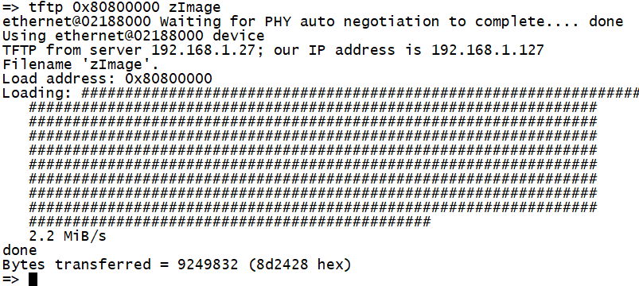
- tftp 0x83000000 myd-y6ull-emmc.dtb
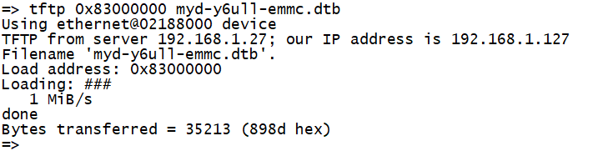
- boot

